Full Paper Preparation for Electrimacs 2014, Valencia, Spain, May 19th-22nd, 2014
L. Vido¹
1. SATIE, University of Cergy-Pontoise, 33 bd du Port, 95000 Cergy-Pontoise, France.
e-mail: lionel.vido@u-cergy.fr
Abstract - The abstract should summarize the content of the paper, indicating its aim, starting point, original contribution and conclusions (up to 200 words).
Keywords – The work should be summarized here with a maximum of six keywords.

Introduction
Participants wishing to submit a paper are kindly invited to upload a six pages full paper using the website: http://www.electrimacs2014.upv.es. Full papers should be prepared using Microsoft Word 1997-2010, OpenOffice/LibreOffice or Latex. Uploaded papers should always be in .pdf format.

General norms

Fonts
The text should have justified right and left margins, in font type Times New Roman, size 10 and are single spaced with no indentations.
Please do NOT number the pages.
The following styles and sizes are to be used (Table I):
I. Document styles
Style | Characteristics
Paper Title (Heading) | 16 pt, bold, centred, small caps, spacing 12pt before and after
Authors’ names | 12 pt, bold, centred.
Affiliation and e-mail | 10 pt, centred.
Titles of each Section (Title 1) | Hierarchical numbered, 11 pt, centred, bold.
Titles of each Subsection (Title 2) | Hierarchical numbered, 11 pt, centred, italic.
Main body text (Normal) | 10 pt, right and left justified.
Figure and table captions | 10 pt, centred.
Table Title | 10 pt, bold.
Table text | 10 pt, right and left justified.

II. Columns
Width of column | 75 mm
Space between columns | 10 mm

III. Margins
Margins
Left | 25 mm,
Right | 25 mm,
Upper | 25 mm,
Lower | 25 mm,

Units
Use either SI (MKS) or CGS as primary units. (SI units are strongly encouraged.) The SI unit for magnetic field strength H is A/m.

Figures and Tables
Large figures, tables and equations should be avoided but may span both columns. In this case, they have to be placed at the end of the document (fig. 3 and (2)). Place figure captions below the figures and table captions above the tables. Please do not include captions as part of the figures. Do not put captions in "text boxes" linked to the figures. Do not put borders around the outside of your figures.
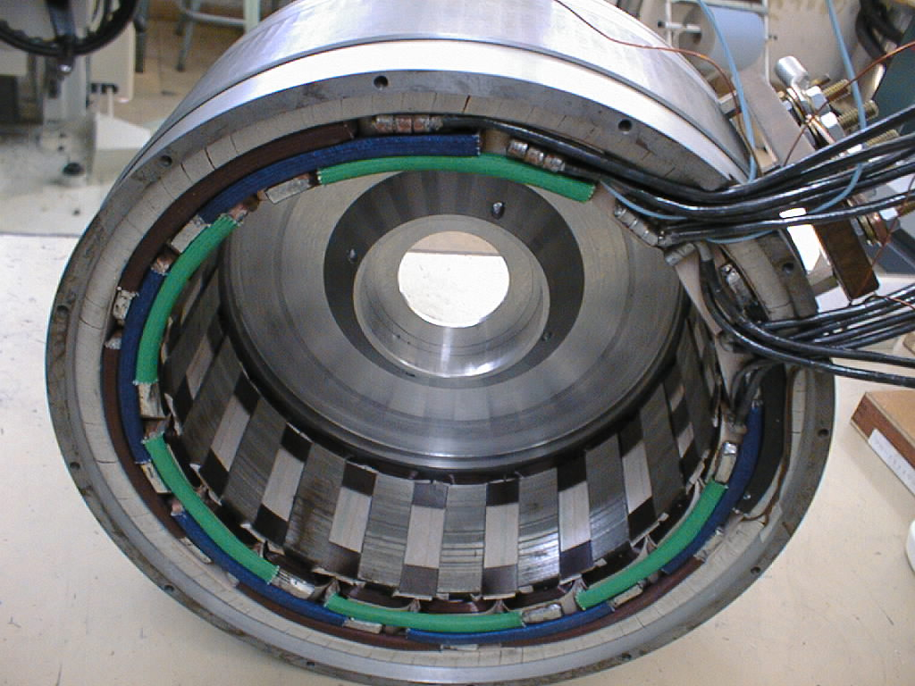
Fig. 1. Hybrid excitation synchronous machine stator.
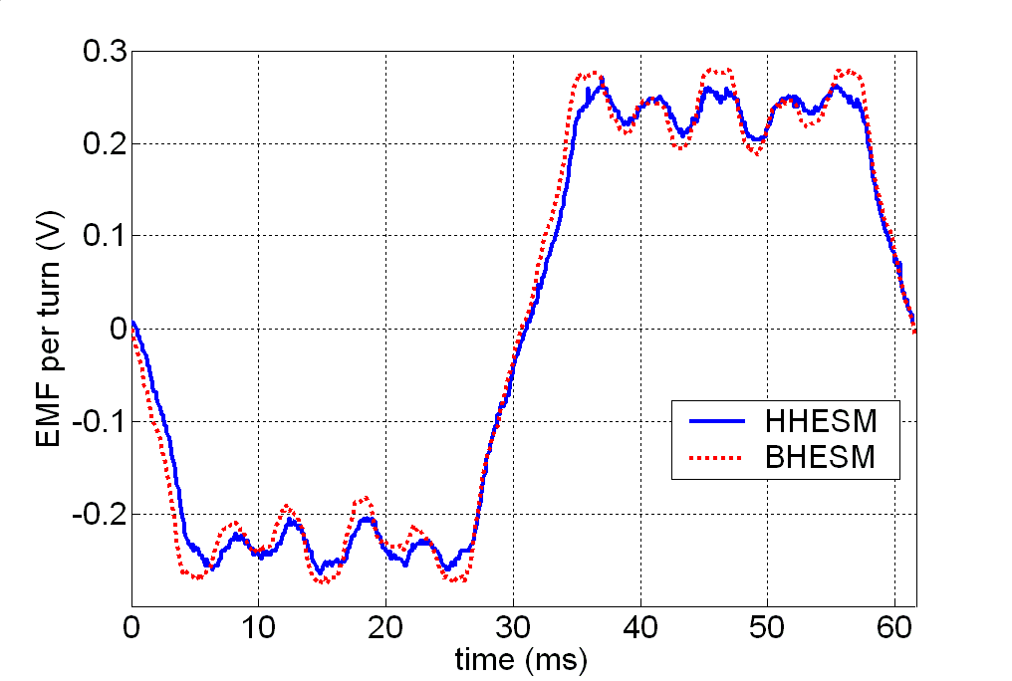
Fig. 2. EMF against time.
Tables are numbered with Roman numerals
IV. Units for Magnetic Properties
Symbol | Quantity
B | magnetic flux density
H | magnetic field strength
μ | permeability

Equations
Number equations consecutively with equation numbers in parentheses flush with the right margin, as in (1).
Expressions and equations must be centred. They need to be numbered as follows:
$$Γ=\frac{1}{2}i_{\text{αβ}}^{T}T_{\text{32}}^{T}\frac{d L}{d θ}T_{\text{32}}i_{\text{αβ}}+\frac{d Φ_{\text{αβ}r}^{T}}{d θ}i_{\text{αβ}}$$
References within the text will have the number of the equation within curved parenthesis, as in the case of (1). Variables will be in Italics, constants in Normal, and matrices in Bold.

References
Citations have to be numbered consecutively in square brackets [1]. The sentence punctuation follows the brackets. Multiple references as [2], [3] are each numbered with separate brackets [1]-[3]. When citing a section in a book, please give the relevant page numbers [2].
In sentences, refer simply to the reference number, as in [1]. Use only the abbreviation “Ref.”. Do not use "Ref. [1]" except at the beginning of a sentence: "Ref. [1] shows ..."
The Reference list must appear numbered in square brackets in the references section and should have the following structure:
- Author(s),
- Title of the work or paper,
- Journal, conference, book or thesis,
- Publisher, in the case of books,
- Place in the case of conferences and theses.
- Volume and page numbers if necessary (example: pp. 32-36),
- Date of publication (with books and theses, the year of publication is sufficient).
Previous Electrimacs conferences or EIC journal citations are welcome.

Acknowledgements
The authors acknowlege...

References
- L. Charaabi, A.A. Naassani, E. Monmasson, I. Slama-Belkhodja and M-H Belmimoun, Choosing FPGA or DSP for control algorithms. The case of the DTC, Electrimacs, Hammamet, Tunisia, 17-20 April 2005.
- N. Patin, L. Vido, E. Monmasson, J.P. Louis, M. Gabsi, and M. Lecrivain, Control of a Hybrid Excitation Synchronous Generator for Aircraft Applications, IEEE Trans. Industrial Electronics, vol. 55, no. 10, pp. 3772–3783, Oct. 2008.
- L. Idkhajine, E. Monmasson, A. Maalouf, FPGA-Based Sensorless Controller for Synchronous Machine using an Extended Kalman Filter, EPE’09 Conference, Barcelona, Spain, 8-10 September 2009.

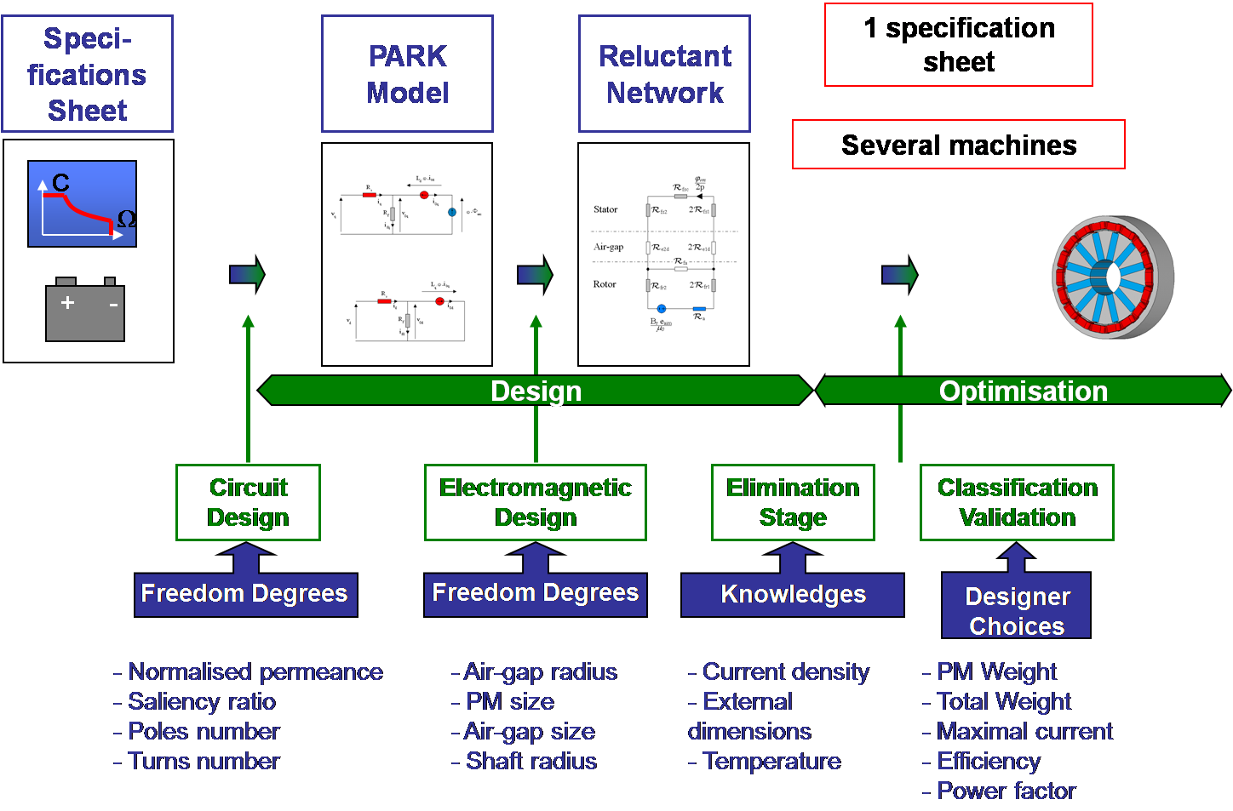
3. Large figure example.
Large equation example:

